Navigation:

cd (change directory): Moves you between directories.

Exercise: Navigate to your home directory (cd ~), then explore subdirectories like Documents (cd Documents). Use pwd (print working directory) to confirm your location. Try going back a directory with cd ...

pwd (print working directory): Shows your current directory path.

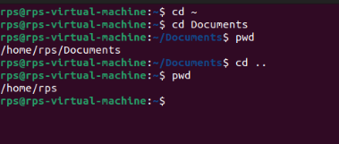

Exercise: After navigating using cd, use pwd to verify the path.

ls (list): Lists files and directories in the current directory.

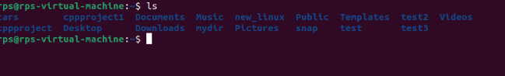

Exercise: Use ls in your home directory and note the listed items. Try ls -l (long format) for detailed information like permissions, owner, and size.

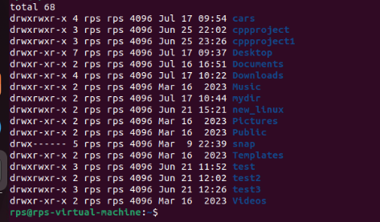

File and Directory Management:

mkdir (make directory): Creates a new directory.

Exercise: Create a new directory called "Projects" (mkdir Projects). Use ls to confirm its existence.

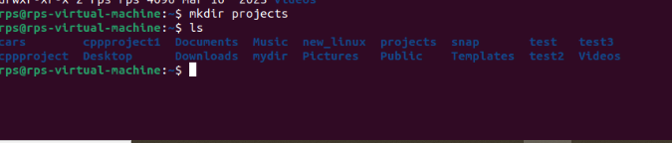

rmdir (remove directory): Deletes an empty directory.

Exercise: Make a directory named "temp" (mkdir temp). Delete it after verifying its existence with ls (rmdir temp).

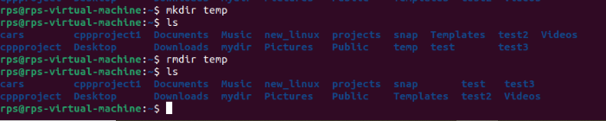

touch (create file): Creates an empty file.

Exercise: Create a file called "test.txt" (touch test.txt). Use ls to see it listed.

cp (copy): Copies a file or directory to another location.

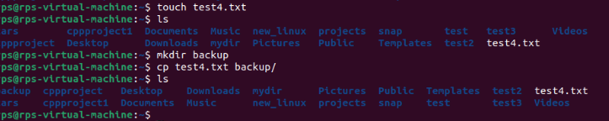

Exercise: Copy "test.txt" to your Documents directory (cp test.txt Documents). Verify the copy with ls Documents.

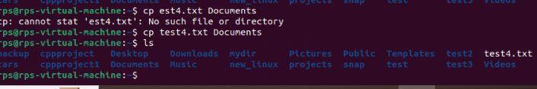

mv (move/rename): Moves or renames a file or directory.

Exercise: Rename "test.txt" to "data.txt" (mv test.txt data.txt). Use ls to confirm the change. You can also move files to a different directory (e.g., mv data.txt Documents).

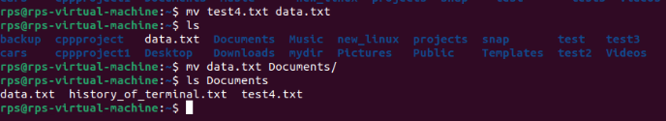

rm (remove): Deletes files or directories (use with caution!).

Exercise: Important: Only use this after creating a test file (e.g., touch temp.txt). Delete "temp.txt" with rm temp.txt. Never use rm -rf without understanding the risks!

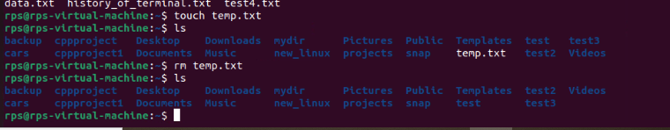

File Viewing and Permissions:

cat (concatenate): Displays the contents of a text file.

Exercise: Create a text file named "message.txt" with some content (e.g., using a text editor). Then, use cat message.txt to view its contents.

more (pager): Displays a file's contents one screen at a time (useful for long files).

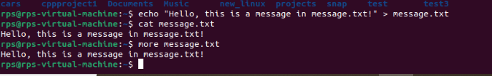

Exercise: Create a larger text file (e.g., "long_text.txt") and use more long_text.txt to navigate through its content page by page.

less (pager): Similar to more, but allows you to move backward in the file.

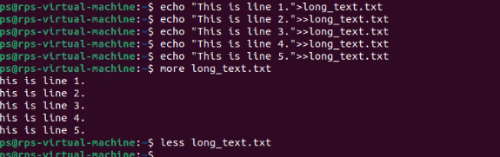

Exercise: Use less with "long_text.txt" to try moving backward using the Up arrow key.

chmod (change mode): Modifies file permissions (owner, group, others) for read, write, and execute access.

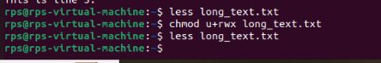

Exercise: This requires understanding permissions. Refer to the man chmod page for details. Proceed with caution when modifying permissions.

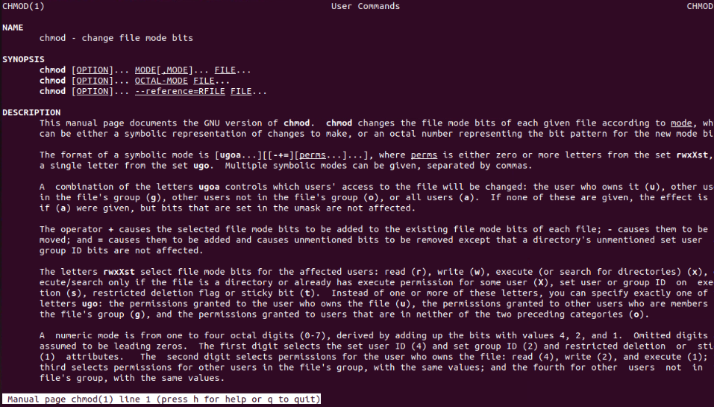

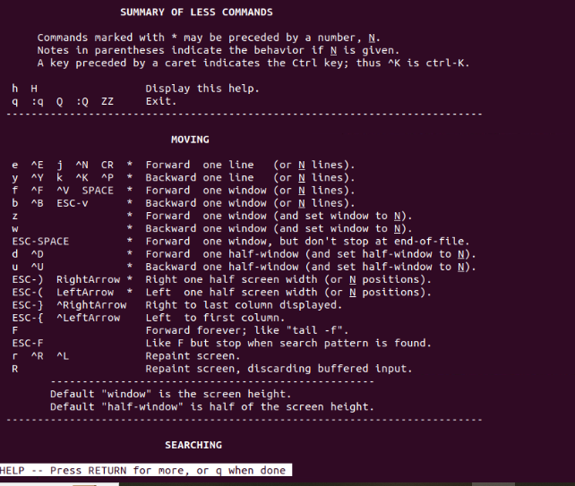

man (manual): Provides detailed information about a command.

Exercise: Use man ls or man cd to learn more about these commands.

info (information): Another source of documentation for some commands, often more user-friendly than man.

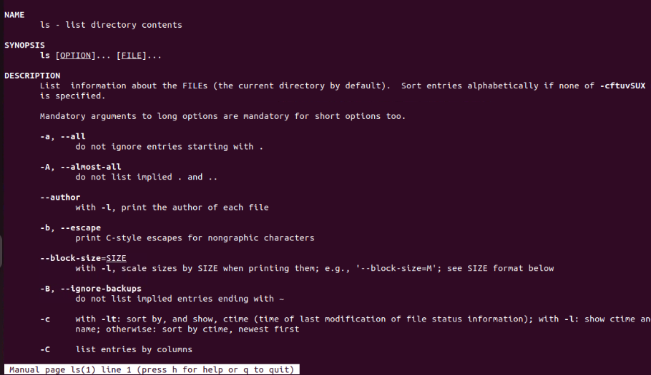

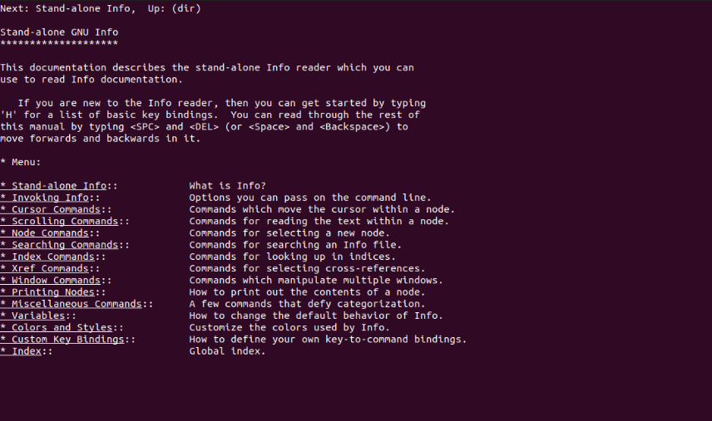

Exercise: Try info ls or info cd if available on your system.

--help or -h (help flag): Provides a brief overview of a command's usage.

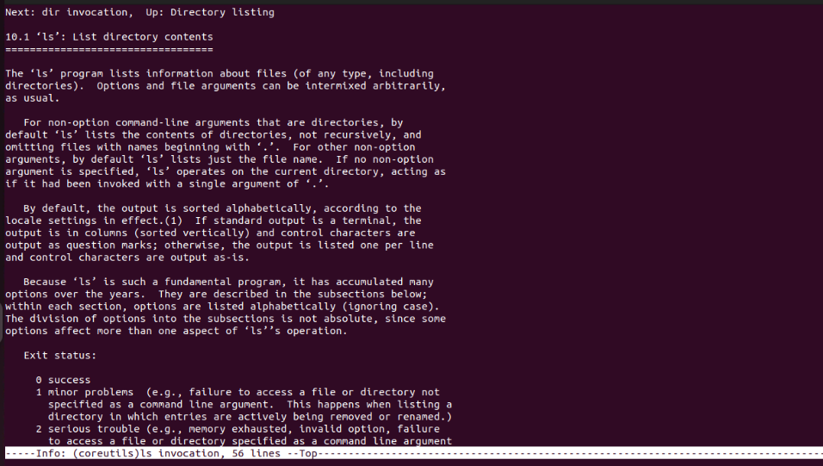

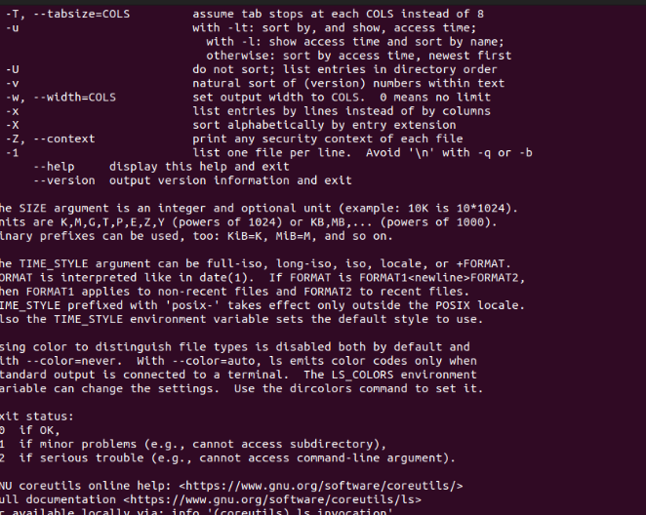

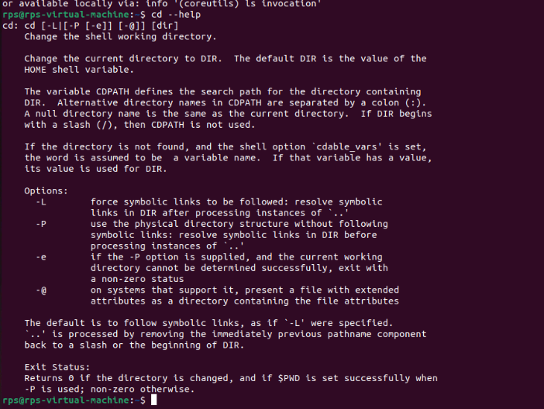

Exercise: Use ls --help or ls -h to see the basic usage options for ls.

